PPG Meeting
16/01/2024 18:30
The Willows Medical Practice

Present: Dr J Amin (Practice GP)
Shaun Jeffers (PM)
Louise Hoare (ANP)
Dawn Orro (DO)
Patients I.D No. 500466 (KS)
9178 (SR)
744 (JC)
Chair – Shaun Jeffers
Minute Taker: Shaun Jeffers
Minutes will be shared on Practice website.
- Introductions: SJ Welcomed all present to the meeting. SJ explained Housekeeping, toilet facilities and Fire Alarms/Emergency exits. Thanked all for coming to the meeting, it had snowed in the morning and was very cold so we had a low attendance than expected to this meeting, however explained feedback is welcomed so we can engage with our patients and understand any frustrations which they may have.
2. Apologies: No apologies made.
3. Minutes from the last meeting: These were reviewed and any actions following the last meeting were discussed. It was noted there were no concerns other than name badges that were raised, and this has now resolved.
After a brief overview of the previous meeting, it was agreed that we would be discussing the below themes:
- MISSION STATEMENT AND VISION
- QUALITY AND OUTCOMES FRAMEWORK (QOF)
- RECENT PATIENT FEEDBACK QUESTIONNAIRE & RESULTS
*Would anyone Patients or Practice staff wish to discuss anything else during this time? *
All parties remained quiet.
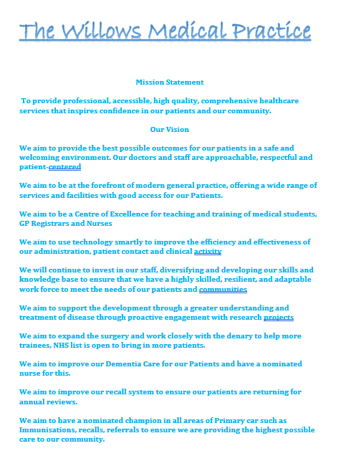
MISSION STATEMENT AND VISION

For the purposes of the meeting, I have shared a copy of our mission statement and vision to all attendees of the PPG meeting. This is also visibly available in our reception area on a poster for patients & staff.
It was explained to all parties that a mission statement typically outlines the purpose, values, and goals of the practice. It serves as a guiding statement that communicates the practice's commitment to providing quality healthcare and its overarching philosophy. SJ asked if all the persons present agreed with the statement and if they felt this should include anything else.
All present people agreed with the statement and felt it covered everything they would expect from their GP Practice. SJ explained that this is reviewed constantly throughout the year to ensure the GP mission statement is relevant to the service.
We then moved onto the Vision. SJ & JA explained that in order to achieve the mission statement, the practice is required to come up with visions on how they would achieve this.
Each vision was discussed and the reasons why this is on the statement.
QUALITY AND OUTCOMES FRAMEWORK (QOF)
SJ explained that The Quality and Outcomes Framework (QOF) is a performance measurement system used in the United Kingdom's National Health Service (NHS). It is designed to assess the quality of primary care services provided by general practices and to link financial incentives to the achievement of specific healthcare standards. The QOF involves a set of indicators covering clinical, organizational, and patient experience domains, with general practitioners (GPs) and practices receiving financial rewards based on their performance against these indicators. This framework aims to improve the quality of care, enhance patient outcomes, and encourage the delivery of evidence-based practices in primary care settings.
The reason why we are discussing this within our PPG meeting is because the better the engagement and understanding we have with our registered patients, the healthier the community becomes and the pressures on the Practice can become more controlled. QOF is designed to ensure the Practice is working towards achieving high standards of care for all patients especially those with complicated medical problems.
SJ explained that we have now entered the final quarter of the financial year for which QOF is measured and wanted to highlight that the main areas we still have some work to do are diabetic reviews, child vaccinations & mental health reviews. We do have challenges with patient attending these appointment and national database compliance concerns relating to the numbers achieved. We are always trying to engage the patients who fall into these categories, and we solely rely on them coming to reviews/assessments and appointments to achieve these targets set by the NHS.
As we move towards the new financial year, we will start to plan for the new QOF year.
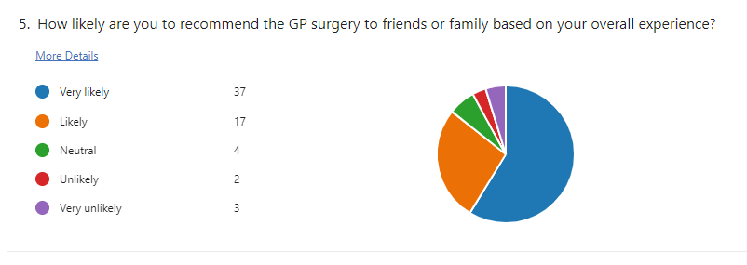
PATIENT FEEDBACK QUESTIONNAIRE AND RESULTS
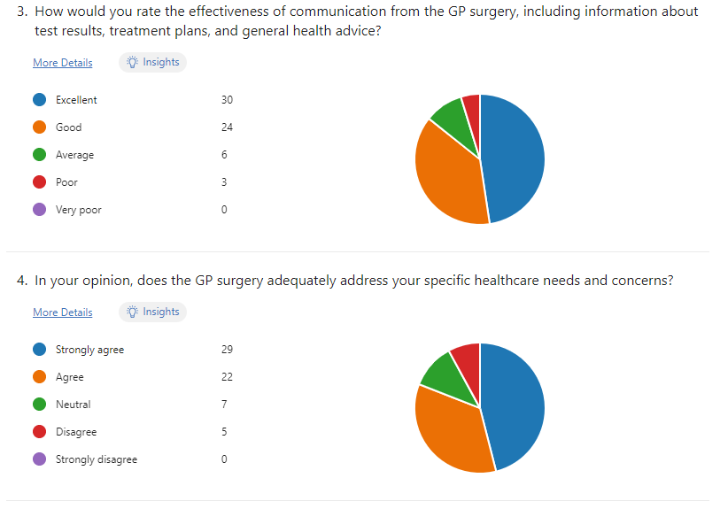
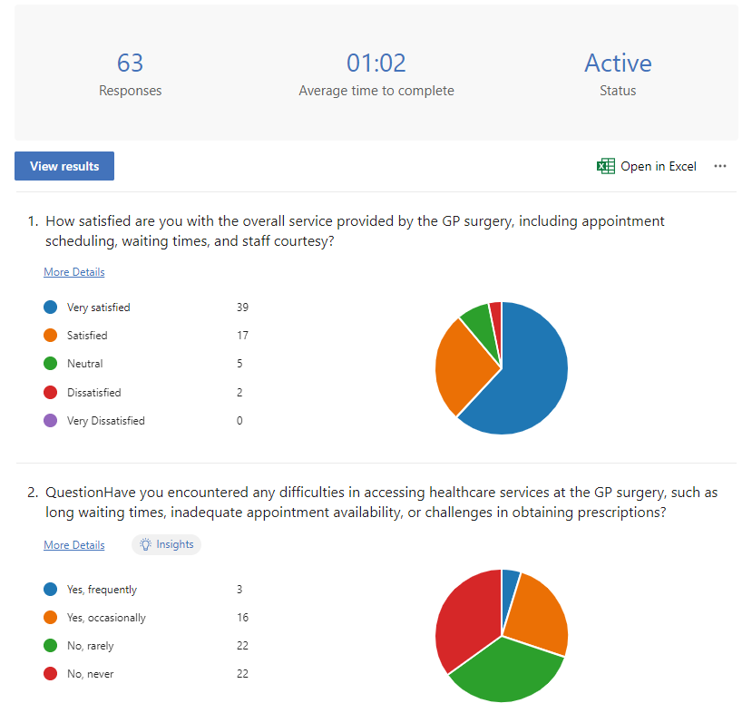

We shared the results from a recent practice survey and discussed each question 1-5.
SJ explained it was great to see that 97% of the 63 responses were happy with the service they received from The Willows Medical Practice, this had been shared at a recent practice meeting and celebrated between the staff.
70% of patients never been faced with difficulties when accessing healthcare. The remaining 30% of patients had highlighted that this happened occasionally, and we are working on further understanding how we can support patients who are experiencing this.
It was also celebrated that 95% of our patients are happy with the effectiveness of the surgery including test results and general health advice.
92% of patients felt that the GP adequately addressed their needs and concerns and as mentioned above a high % of these were then happy with the speed of which these needs and concerns acted on and communicated back to the patient.
And finally, 92% of our patients would recommend the surgery to a friend or family member. This is something we are incredibly proud to showcase to the public. The healthcare and services we are providing is matching the expectation of our patients.
We do however understand as we previously discussed that we do like feedback, this is how we continue to provide this high level of care for our patients. Please feel free if you have any discussions about the above?
SR – Results that have been presented really show we are doing the right thing for patients, from personal experience staff and GPs have always supported her and family.
JA – Thanked for feedback.
Open to discussion.
Pick up on any other topics people wish to discuss from the agenda topics*
6. Practice Update & AOB
Shaun thanked everyone for attending especially on such a cold evening, but feedback is essential in our journey to continue high service for our patients. All patients agreed, the feedback reflected that of the recent questionnaire we had sent out being very good and that they couldn’t complain. SJ advised we do welcome patient feedback in all forms, email, face to face, telephone – good or bad and patients can give this feed back to anyone they see. We have a robust process in place for acting on feedback to ensure we are listening and responding to patients and sharing the feedback we receive to improve on our service.
SJ - Any other business?
JA – No
SJ – Thanks and closed the meeting : 19:25
Date of next meeting
27th August 2024
Meeting Closed At: 19:15

