**The Willows Surgery Complaints Procedure.**

Most NHS care and treatment goes well but sometimes things can go wrong. If you are unhappy with your care or the services you have received, it is important to let us know so that we can improve.

There are 2 ways to tell the NHS what you think:

* give feedback
* make a complaint

**1. Giving feedback**

Feedback helps us improve the quality of your care. You can give good or bad feedback by telling the NHS organisation or service about it. For example, you can do this through the ‘Friends and Family Test’, or, you can speak to a member of staff.

Other ways to give feedback should be clearly displayed at the service you visit.

If you are unhappy with an NHS service, it is worthwhile discussing your concerns early on with the provider of the service, as they may be able to sort the issue out quickly. Most problems can be dealt with at this stage but, in some cases, you may feel more comfortable speaking to someone not directly involved in your care.

**2. How to make a complaint**

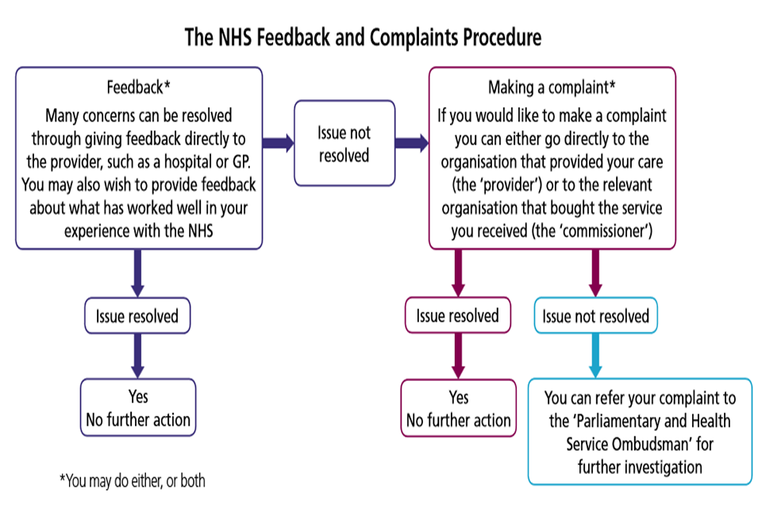

When making a complaint, you can choose to complain to either:

* the healthcare provider: this is the organisation where you received the NHS service, for example your hospital, GP surgery or dental surgery
* the commissioner: this is the organisation that paid for the service or care you received

The commissioner will vary depending on the NHS service you are complaining about.

If your complaint is about primary care services such as GPs, dentists, opticians or pharmacy services, contact NHS England.

If your complaint is about services such as hospital care, mental health services, out-of-hours services and community services such as district nursing, contact your local clinical commissioning group.

Complaining to the commissioner may be the right option if you are not comfortable complaining direct to your healthcare provider, or if you feel this is not appropriate.

You can complain in writing to the Practice by way of letter directed to:

Lords Avenue, Salford, Manchester, M5 5JR.

By emailing, [willowssurgery.prescriptions@nhs.net](mailto:willowssurgery.prescriptions@nhs.net) or by speaking to someone in the Practice.

You should make your complaint within 12 months of the incident, or within 12 months of the matter coming to your attention. This time limit can sometimes be extended as long as it is still possible to investigate your complaint.

Anyone can complain, including young people. A family member, carer, friend, or your local MP, can complain on your behalf with your permission.

**3. What to expect after making a complaint**

You should:

* have your complaint acknowledged and properly looked into
* be kept informed of progress and told the outcome
* be treated fairly, politely and with respect
* be sure that your care and treatment will not be affected as a result of making a complaint
* be offered the opportunity to discuss the complaint with a complaints manager
* expect appropriate action to be taken following your complaint

**4. Getting help with making a complaint**

Making a complaint can seem difficult, but support is available.

Contact your local council or local Healthwatch to find out about independent NHS complaints advocacy services in your area.

Contact your local citizens’ advice bureau for support with complaints about the NHS, social services or local authorities.

Most hospitals have a Patient Advice and Liaison Service (PALS), who provide confidential advice, support and information to patients, their families and carers. Contact the hospital or visit their website for more details.

**5. If you’re not happy with the response to a complaint**

If you are still not happy with the response provided, you can ask the independent [Parliamentary and Health Service Ombudsman](http://www.ombudsman.org.uk/make-a-complaint) to look at your complaint.

Parliamentary and Health Service Ombudsman  
Millbank Tower  
Millbank  
London, SW1P 4QP  
Phone: 0345 015 4033

For public health services complaints, contact the [Local Government Ombudsman](http://www.lgo.org.uk/).

The [NHS Constitution](https://www.gov.uk/government/publications/the-nhs-constitution-for-england) sets out your rights as a patient, and explains the commitments the NHS has made to providing you with a high-quality service. Organisations providing NHS care must take account of the NHS Constitution when treating you, so you may find it helpful to refer to it if you are thinking about making a complaint.

**6. Useful contact details**

**Healthwatch**

To find the contact details for your local Healthwatch, visit the [Healthwatch website](https://www.healthwatch.co.uk/) or call Healthwatch England on 03000 68 3000.

**Citizens Advice**

You can contact [Citizens advice](https://www.citizensadvice.org.uk/) by calling 0344 411 1444.

**Primary care complaints (for example, GPs, dentists)**

Write to:

NHS England  
PO Box 16738  
Redditch, B97 9PT

Email: [england.contactus@nhs.net](mailto:england.contactus@nhs.net) Phone: 0300 311 2233