**PPG Meeting**

**30/08/2024 18:00**

**The Willows Medical Practice**

**Present: Dr J Amin (Practice GP)**

**Shaun Jeffers (PM)**

**Louise Hoare (ANP)**

**Dawn Orro (DO)**

**Patients I.D No. 500466 (KS)**

**9178 (SR)**

**744 (JC)**

**3415 (KW)**

**Chair – Shaun Jeffers**

**Minute Taker: Shaun Jeffers**

**Minutes will be shared on Practice website.**

1. **Introductions: SJ Welcomed all present to the meeting. SJ explained Housekeeping, toilet facilities and Fire Alarms/Emergency exits. Thanked all for coming to the meeting, SJ explained feedback is welcomed so we can engage with our patients and understand any frustrations which they may have.**

**2. Apologies: No apologies made.**

**3. Minutes from the last meeting: These were reviewed and any actions following the last meeting were discussed. It was agreed that there were no actions taken from the previous meeting.**

**After a brief overview of the previous meeting & a based on practice requirements, it was agreed that we would be discussing the below themes:**

1. **PATIENT FEEDBACK QUESTIONNAIRE & RESULTS**
2. **NHS APP & DOWNLOAD**
3. **LOW UPTAKES FOR CHILDREN/YOUNG PEOPLE FOR ASTHMA & IMMUNISATIONS**
4. **AC1 – SALFORD STANDARDS**
5. **AOB. NEW TRAINEES**

**\*Would anyone Patients or Practice staff wish to discuss anything else during this time? \***

All parties remained quiet.

**PATIENT FEEDBACK QUESTIONNAIRE AND RESULTS**

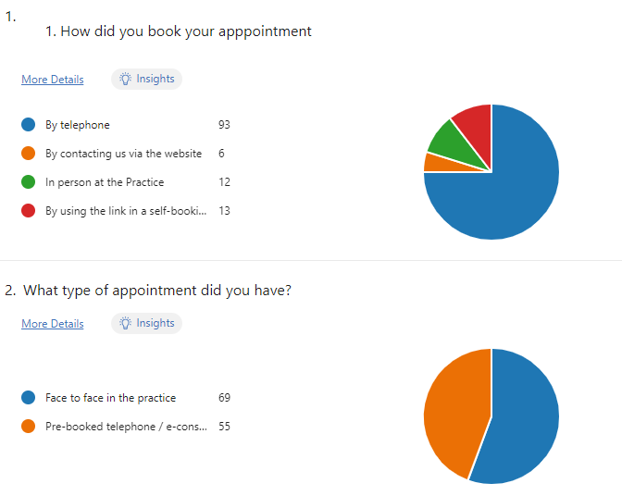

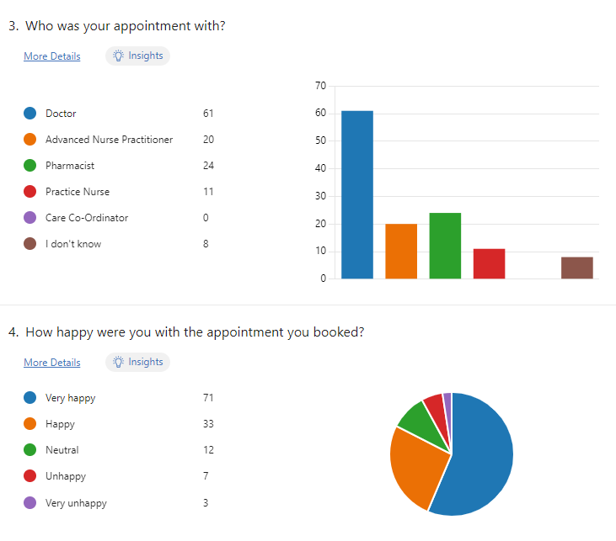

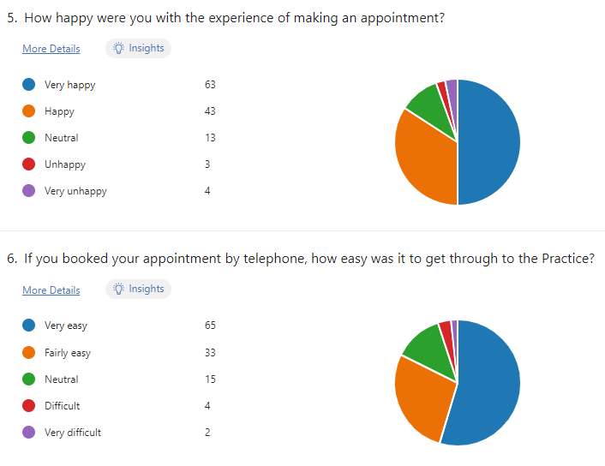

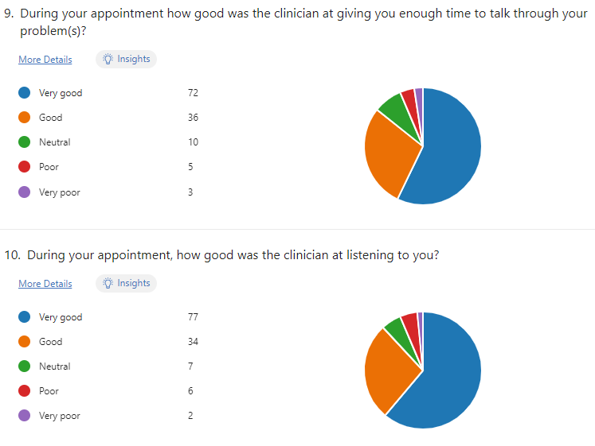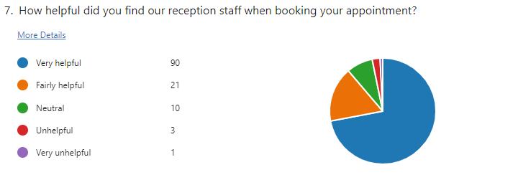

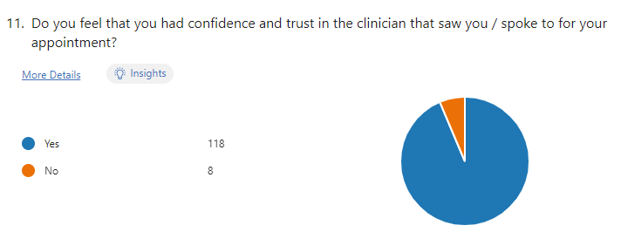

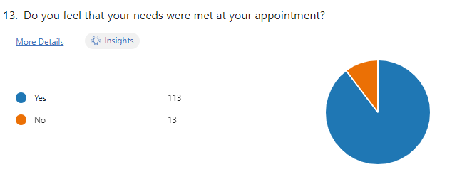

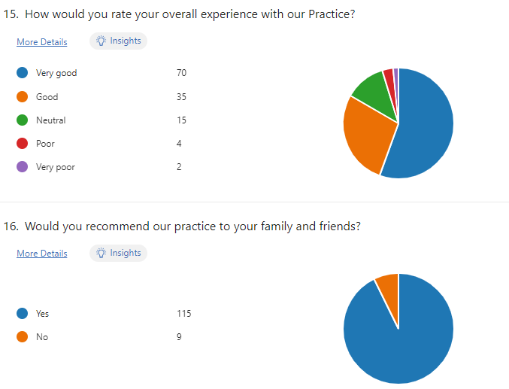

**Analysis**

We could see from the responses shared by our patients that more patients were coming into the Practice 69 f2f vs 55 via telephone and the majority of appointments were to see a GP which was to be expected.

91% of patients were happy with the appointment they had booked, some of the key words used to describe the appointments were, HELPFUL, GOOD, FRIENDLY, UNDERSTANDING.

94% of our patients told us they were happy with the booking experience and how easy it was to obtain an appointment, and 95% told us it was easy to get through when booking on the phone. This was fantastic feedback showing great availability to see the requested service and also showing great communication over the phone when trying to get through to our team.

Overall, a massive 95% told us they were happy with the overall experience with our Practice. This is testament to the hard work we all put in and through listening and responding to patient feedback. We wanted to thank our patients for the fantastic feedback they had given and let them know every single message is read.

We love feedback and want our patients to know they can provide feedback in anyway which is suitable to them.

JA – Thanked for feedback.

**NHS APP activity - https://www.nhs.uk/nhs-app/**

The Practice had agreed at the start of the year to increase the number of patients who had:

1. Downloaded the NHS app.
2. Were using the NHS app to its capacity.

We wanted our patients to know that we were here to help support all demographics with our aim to increase the number of users on the NHS app. We are also working with our NHS Integrated Care Board (ICB) to promote in practice support with the less technically aided patients and the ICB will focus on these patients to help and show them how to use the app. We sent a text message out initially in March 2024 to patients over 65 years old for an NHS app download event which was highly successful. **We aim to do this again in November 2024 and open it up to more demographics.**

We have been monitoring activity/downloads for the last 12 Months. During the Month of June 2023 our patients signed into the NHS app 639 times, our latest data for June this year shows an increase of 699 log ins taking our total to 1338 log ins in June 2024. This data also shows the number of downloads is increasing and our patients are using it more.

The main benefit to having the NHS app is that you can request repeat medication directly with the GP. This was a feature we were using to promote in the practice. More features could be seen using the link above.

Data shows that we had a high increase in NHS downloads over 2021 – 2022 (this is when the app relaunched) and since then there have been a steady number of downloads, this is inline with national figures. Our aim now is to increase awareness of new features since launched and offer support to our patients to use the NHS app.

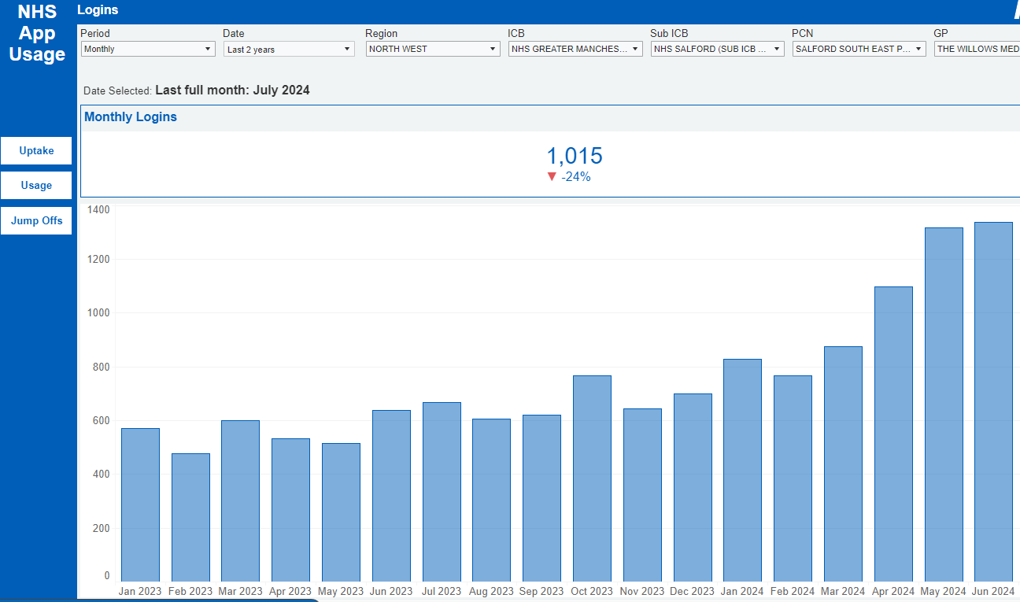

**LOW UPTAKES FOR CHILDREN/YOUNG PEOPLE FOR ASTHMA & IMMUNISATIONS**

Dr Amin wanted to highlight that the Practice had seen low uptake on the above cohort of patients. We have 11 children and young people who have asthma, and it is critical that these patients have an annual review to ensure they are getting the right support to treat their condition. We had only seen 5 of these patients in the previous 12 Months despite inviting them in. We also have many children outstanding vaccinations; this can have a huge impact on a child’s development and the uptake of vaccinations decreasing was having an impact on the health population (most recently we have seen an outbreak of Measles which was in the news).

To support the appointments, we arranged out of school hour clinics including additional appointments in half terms. Invites were sent out in letters, text messages, attempted phone calls to no avail. We also sent out key health information to families of those living with a child with Asthma or outstanding child vaccinations. We wanted to share this information in our PPG group and minutes shared online (practice website) to try to increase awareness regarding the low uptake in this cohort of patients.

**AL1 – SALFORD STANDARDS Addressing Inequalities Core20PLUS5 project**

We are working on a project to increase cancer screening by 12% by March 2025 and we wanted to share this with our Patients. This Project will be run by our Care Co-ordinator Maria.

Our main focus areas will be:

* We aim to review national and local cancer data to understand any trends in the locality.
* Review our uptake rates for cancer screening programmes such as breast, cervical, and colorectal cancer.
* Using recent audit data to explore the processes and timing of referrals to secondary care.
* Identify and study cases of diagnostic delay from initial presentation to final diagnosis.
* Review information on patient demographics to identify high-risk groups and differences in diagnostic aspects.

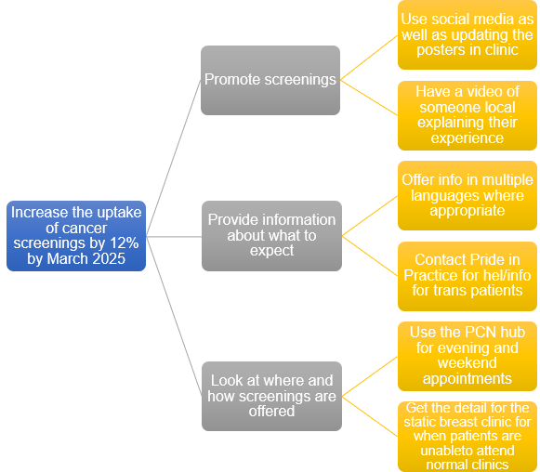

More information on the outcomes of this project will be shared in the Practice at the end of the year on our notice board.

**6. Practice Update & AOB**

**Shaun thanked everyone for attending especially on such a rainy evening, but feedback is essential in our journey to continue high service for our patients. All patients agreed, the feedback reflected that of the recent questionnaire we had sent out being very good and that they couldn’t complain. SJ advised we do welcome patient feedback in all forms, email, face to face, telephone – good or bad and patients can give this feed back to anyone they see. We have a robust process in place for acting on feedback to ensure we are listening and responding to patients and sharing the feedback we receive to improve on our service.**

We wanted to make our patients aware that we have new medical trainees starting with the Practice this week working under the supervision of Dr Amin.

**SJ - Any other business?**

**JA – No**

**SJ – Thanks and closed the meeting: 18:25**

**Date of next meeting**

**18th March 2025**

**Meeting: 18:00**