**PPG Meeting**

**30/08/2024 18:00**

**The Willows Medical Practice**

**Present: Dr J Amin (Practice GP)**

**Shaun Jeffers (PM)**

**Louise Hoare (ANP)**

**Maria Fenton (CC)**

**Patients attended x 6**

**Chair – Shaun Jeffers**

**Minute Taker: Shaun Jeffers**

**Minutes will be shared on Practice website & will also be available in a paper copy at reception.**

1. **Introductions: SJ Welcomed all present to the meeting. SJ explained Housekeeping, toilet facilities and Fire Alarms/Emergency exits. Thanked all for coming to the meeting, SJ explained feedback is welcomed so we can engage with our patients and understand any frustrations which they may have.**

**2. Apologies: No apologies made.**

**3. Minutes from the last meeting: These were reviewed and any actions following the last meeting were discussed. It was agreed that there were no actions taken from the previous meeting.**

**After a brief overview of the previous meeting & based on practice requirements, it was agreed that we would be discussing the below themes:**

1. **PATIENT FEEDBACK QUESTIONNAIRE & RESULTS**
2. **PRACTICE INVOLVEMENT/AUDITS**
3. **NHS APP & DOWNLOAD**
4. **AC1 – SALFORD STANDARDS**
5. **AOB. NEW TRAINEES**

**\*Would anyone Patients or Practice staff wish to discuss anything else during this time? \***

All parties remained quiet.

**PATIENT FEEDBACK QUESTIONNAIRE AND RESULTS**

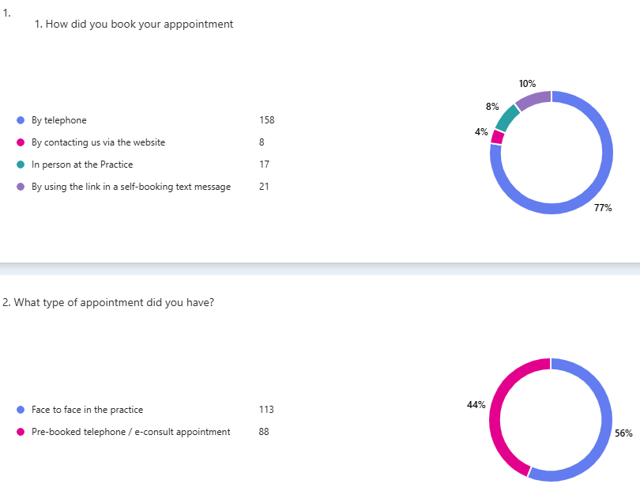

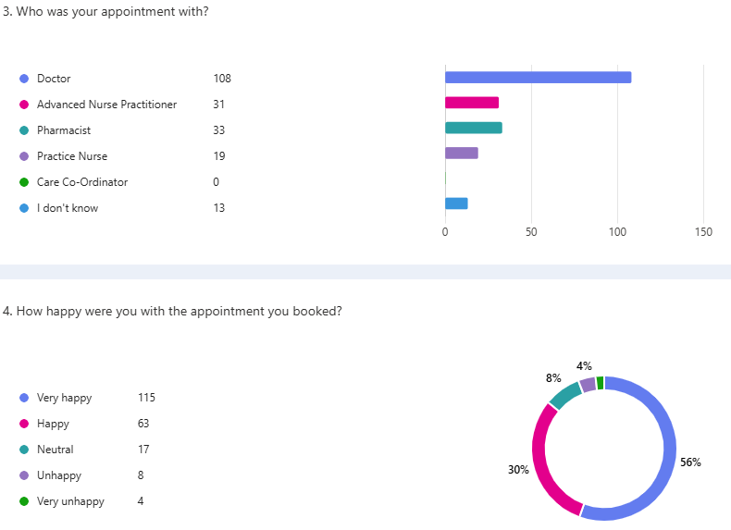

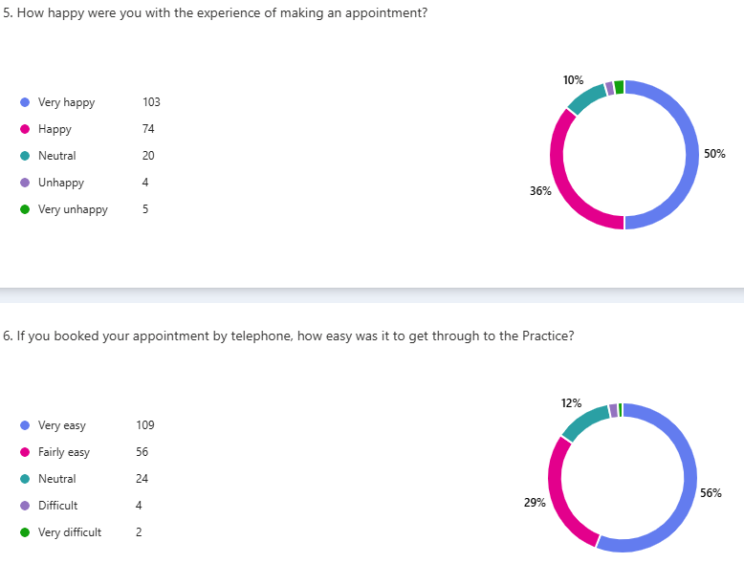

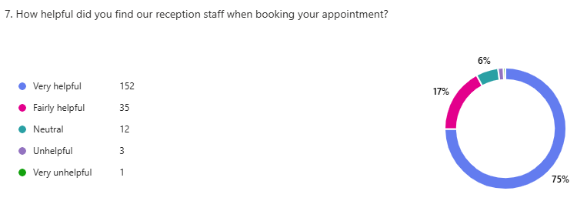

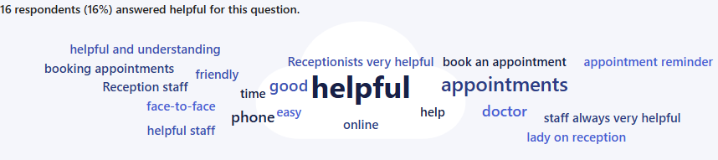

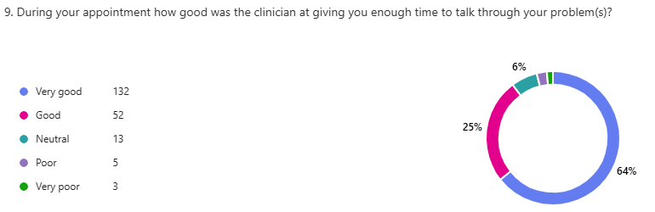

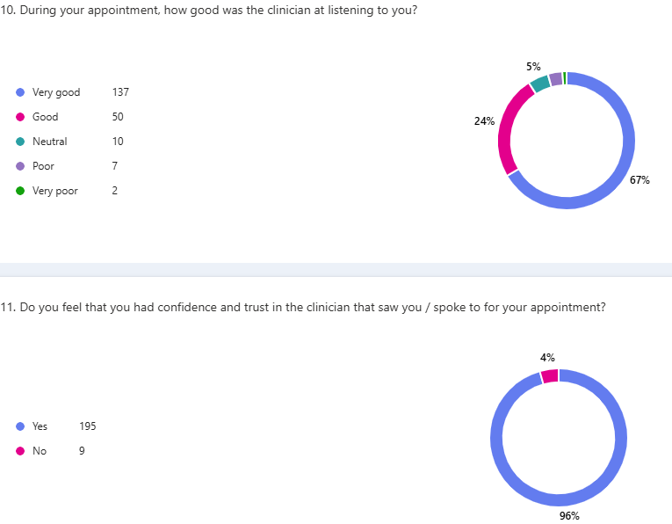

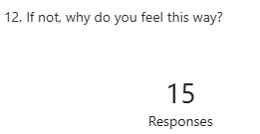

**Response investigations**

Out of 15 responses 8 responses were “N/A”. 5 related to “Not listening” to concerns, 1 for medical records not transferred from previous GP and 1 for not having knowledge around a problem raised. The common theme was around not listening, this information was taken to our recent Practice Meeting although this feedback is common amongst only 2.4% of the feedback returned we can use this as ways to reflect.

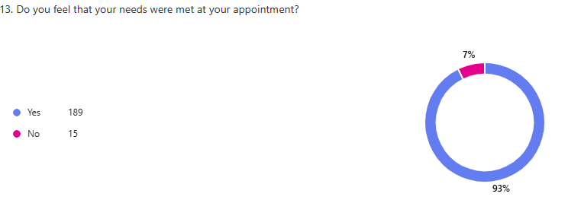

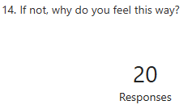

**Response investigations**

Out of the 20 responses shown, 8 comments were “n/a”. Other 12 feedback was generally around ongoing problems which were being investigated by the GP by doing further tests or referrals etc.

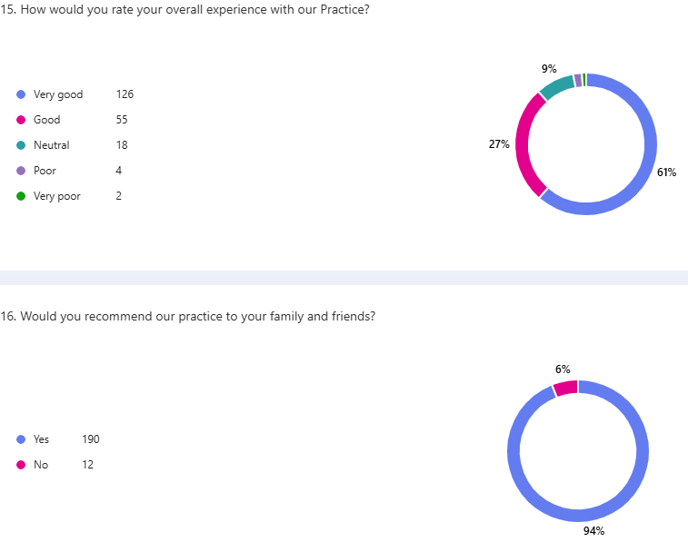

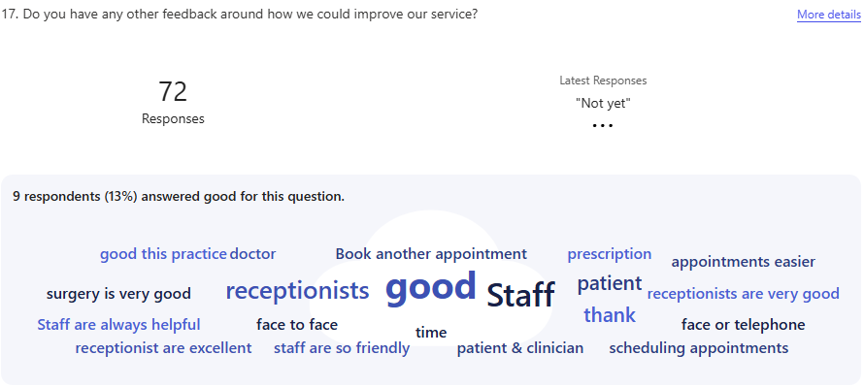

**This patient feedback report is collated on a Monthly basis using patients who have attended the GP and the information is then distributed into the Monthly Practice Meetings.**

JA – Thanked for feedback.

Patients discussed if they felt this was reflective of their experience and if they had any further comments:

*** expressed difficulty of sometimes getting through on the phone in the morning, SJ – we had encouraged patients to use the online triage where possible however we know not everyone can do this, we have restricted some non-urgent phone lines (such as prescriptions and general enquiries) to later in the morning to allow for those who need to get through. We continue to monitor this on our phone line data each Month.

**PRACTICE INVOLVMENT/AUDITS**

SJ – We wanted to share recent success with you of obtaining gold standard for LGBTQ+ and Safeguarding Adults and Children. These were recent audits carried out by external bodies who do not form part of The Willows Medical Practice, and we wanted to highlight the great job the practice was doing in these areas. Dr Amin acknowledged that we are always wanting to learn and work on areas of improvement and by having these audits we are continuing to improve the way we work.

All parties were impressed with the recent audits and felt they wouldn’t have known this if they hadn’t attended the meeting.

SJ highlighted that this is available on the website and also, we share the information in the waiting room.

**NHS APP activity -** [**https://www.nhs.uk/nhs-app/**](https://www.nhs.uk/nhs-app/)

It was recognised that Monthly log ins had more than doubled over the last 6 Months and the downloads had increased by nearly 10% and continued to increase. Patients were made aware that there was many more things which were available to patients on the NHS app now including information on recent referrals and medication requests.

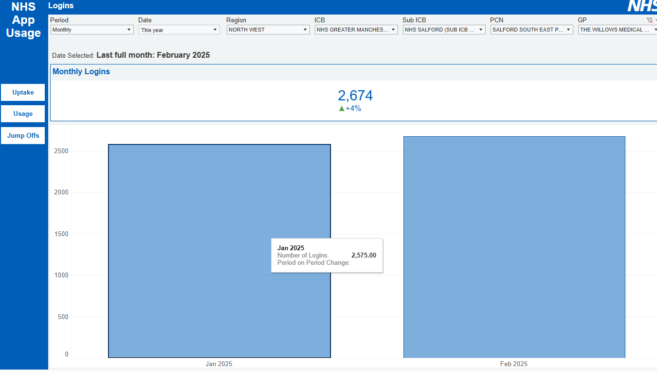

Patients raised that NHS App is useful but sometimes it can cause anxiety when checking test

results and see ‘abnormal’ or ‘out of range’. Noted that clinicians would

always call a patient if the issue is urgent. Often abnormal results are only

slightly out of range so to look for the comments such as ‘routine follow up’ as

this should reassure.

NHS App proxy access limited at The Willows – could this be made more available to parents and carers? We understand the convenience of proxy access and will carefully consider this option to ensure policies in place for safeguarding and confidentiality and time taken to train staff. **In progress**

**AL1 – SALFORD STANDARDS Addressing Inequalities Core20PLUS5 project**

Following on from the previous minutes we wanted to share the updates to this fantastic project Maria, our Care Co-ordinator had been working on:

We plan to split the current group of patients who are outstanding breast screenings to see if they respond better to calls or letters in regard to attending the screening.

For the purpose of the plan, we are going to put patients whose first language is not English, into the ‘letters’ group and this will ensure that we can send out the information in a language that is accessible to them and brings all the patients together in the same way.

Patients who receive a letter will be given information on breast screenings and why they are important. If they have any other needs for example, patients with learning disabilities will be offered an ‘easy read’ version, this will be sent out to them.

Patients who receive a call will be asked if there is a reason they have not attended for their screening. We will then offer any help/support in booking them an appointment.

We are aware that our cohort of patients were invited into the van last year, so we know that the numbers may not be big, which is why the main focus group will be patients who have never had a screening. These are most likely going to be the patients who have no idea what a screening is or why they have it. With the van being in the area until the new year, we may not see our numbers change much until then. We will follow this into the new year.

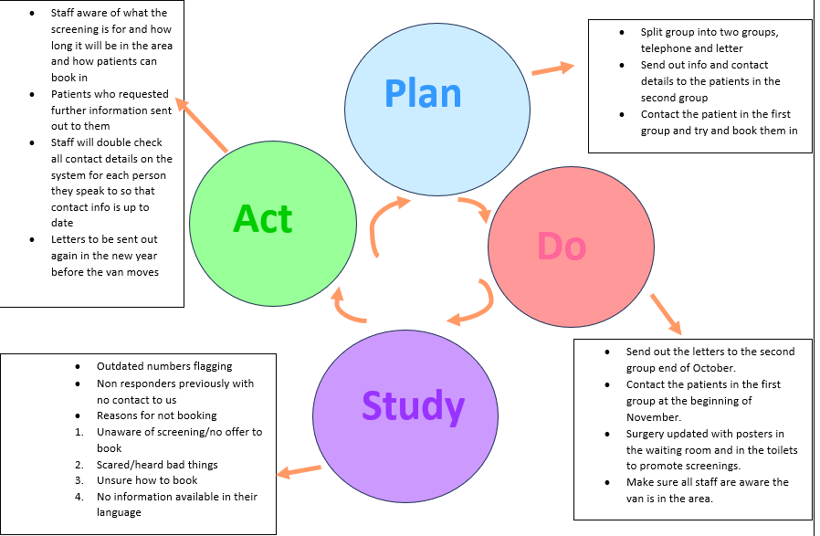

More information on the outcomes of this project will be shared in the Practice at the end of the year on our notice board.

**6. Practice Update & AOB**

**Shaun thanked everyone for attending especially on such a rainy evening, but feedback is essential in our journey to continue high service for our patients. All patients agreed, the feedback reflected that of the recent questionnaire we had sent out being very good and that they couldn’t complain. SJ advised we do welcome patient feedback in all forms, email, face to face, telephone – good or bad and patients can give this feed back to anyone they see. We have a robust process in place for acting on feedback to ensure we are listening and responding to patients and sharing the feedback we receive to improve on our service.**

We wanted to make our patients aware that we have new medical trainees starting with the Practice this week working under the supervision of Dr Amin.

**SJ - Any other business?**

**JA – No**

**SJ – Thanks and closed the meeting: 18:25**

**Date of next meeting**

**18th March 2025**

**Meeting: 18:00**